- Add Loading.png and Weston.ini file on /home/torizon location.
- Nano Weston.ini add below content same as it is:
[core]
idle-time=0

[shell]
background-image=/home/torizon/Loading.png
background-type=scale

- Pass path to .yaml file to image torizon-weston same as below:
-/home/torizon/weston.ini:/etc/xdg/weston/weston.ini
- /home/torizon/Loading.png:/home/torizon/Loading.png
services:
weston:
image: torizon/arm32v7-debian-weston
restart: always
privileged: true
network_mode: host
volumes:
- /tmp:/tmp
- /dev:/dev
- /run/udev:/run/udev
-/home/torizon/weston.ini:/etc/xdg/weston/weston.ini
- /home/torizon/Loading.png:/home/torizon/Loading.png
cap_add:
- CAP_SYS_TTY_CONFIG
device_cgroup_rules:
- 'c 4:* rmw'
- 'c 13:* rmw'
- 'c 226:* rmw'
- 'c 10:223 rmw'

app:
image: intersense123/octo:3
privileged: true
restart: always
depends_on:
- weston
environment:
- QT_QPA_PLATFORM=wayland
- WAYLAND_DISPLAY=wayland-0
- XDG_RUNTIME_DIR=/tmp/1000-runtime-dir
volumes:
- /tmp:/tmp
- /dev:/dev
- /run/udev:/run/udev
- /media:/media
- /sys:/sys
- /etc/machine-id:/etc/machine-id:ro
- /etc/localtime:/etc/localtime:ro
- /etc/timezone:/etc/timezone:ro
- /var/run/systemd:/var/run/systemd
- /run/dbus:/run/dbus
- /home/torizon/Precigo/precigo.db:/home/torizon/app/precigo.db
- /home/torizon/Precigo/OctoPreciGo.db:/home/torizon/app/OctoPreciGo.db
- /home/torizon/Precigo/Octo_CSV:/home/torizon/app/Octo_CSV
devices:
- /dev/ttymxc0
- /dev/rtc0
- /dev/rtc1
cap_add:
- SYS_TIME
- NET_ADMIN
- SYS_BOOT
device_cgroup_rules:
- 'c 13:* rmw'
network_mode: host

# To Get remote access do Below steps:
- Create folder custom -> add Loading.png and weston.ini in it.
- On weston.ini :
[core]
idle-time=0
modules=screen-share.so
[shell]
background-image=/home/torizon/custom/Loading.png
background-type=scale
3)on docker-compose.yml
services:
weston:
image: torizon/weston:$CT_TAG_WESTON
restart: always
privileged: true
network_mode: host
ipc : host

environment:
- ENABLE_RDP=1
- RDP_PORT=3389

command: >
--developer
--tty=/dev/tty7
--
--config=/etc/xdg/weston/weston.ini
--use-pixman

volumes:
- /tmp:/tmp
- /dev:/dev
- /run/udev:/run/udev
- /home/torizon/custom:/etc/xdg/weston/
- /home/torizon/custom/Loading.png:/home/torizon/custom/Loading.png

cap_add:
- CAP_SYS_TTY_CONFIG

device_cgroup_rules:
- 'c 4:* rmw'
- 'c 13:* rmw'
- 'c 226:* rmw'
- 'c 10:223 rmw'

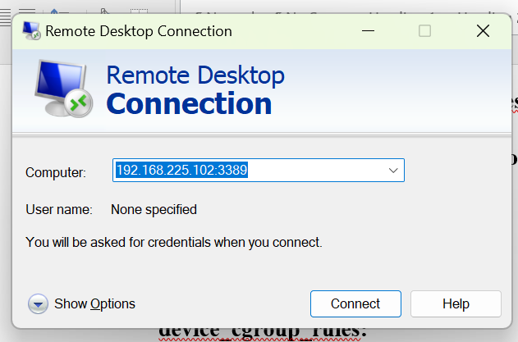
After that click on search on Pc and open remote Desktop Connection always use port :3389 -> click connect

